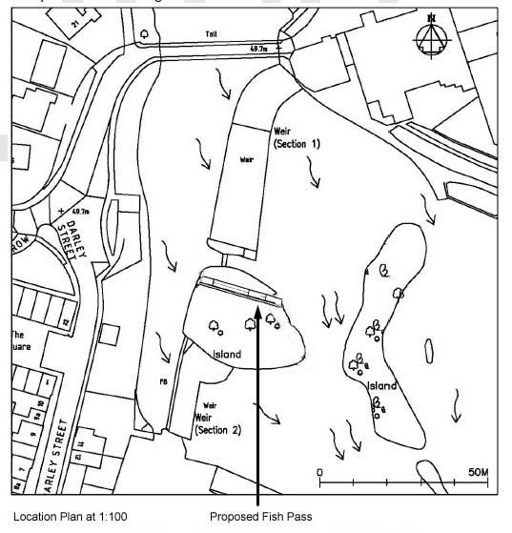
Location Plan @ 1:1250 Proposed fish pass

