.

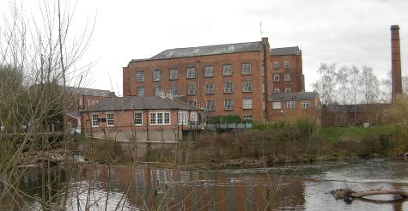

The classic view of the Mills across the river

The upstream wall of the island proposed for the upstream entrance to the fish pass

