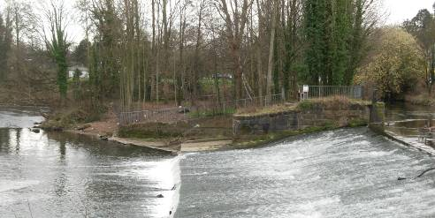
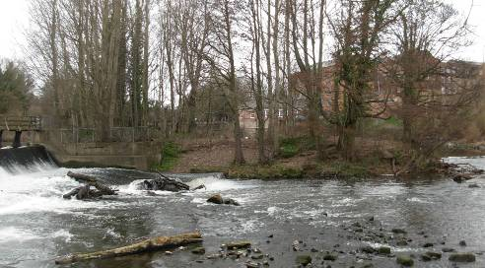
View across the weir from the Toll bridge showing the impact of the existing metal railings.

These are proposed to be replaced with open post and rail wooden fencing.

The current ( May 2012 ) view across the island to the Mill Complex. The overgrown and un kempt appearance of the vegetation is very apparent. There is scope for thinning of the trees as well as new planting to provide enhanced views of the heritage asset.

