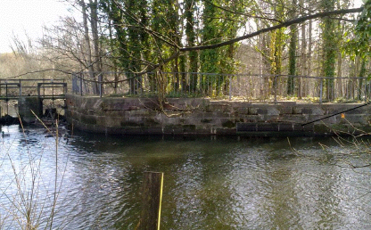
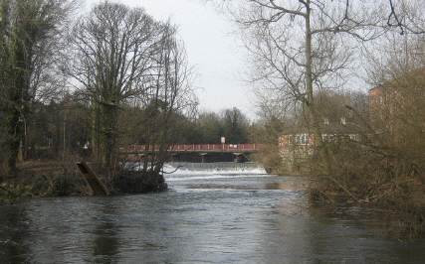
Visualisation of the up-stream entrance to the fish pass which is barely detectable as a ‘letter box’ opening in the reinstated masonry wall.

Visualisation of the down-stream entrance to the fish pass showing the effect of the timber cladding in reducing its visual impact.

