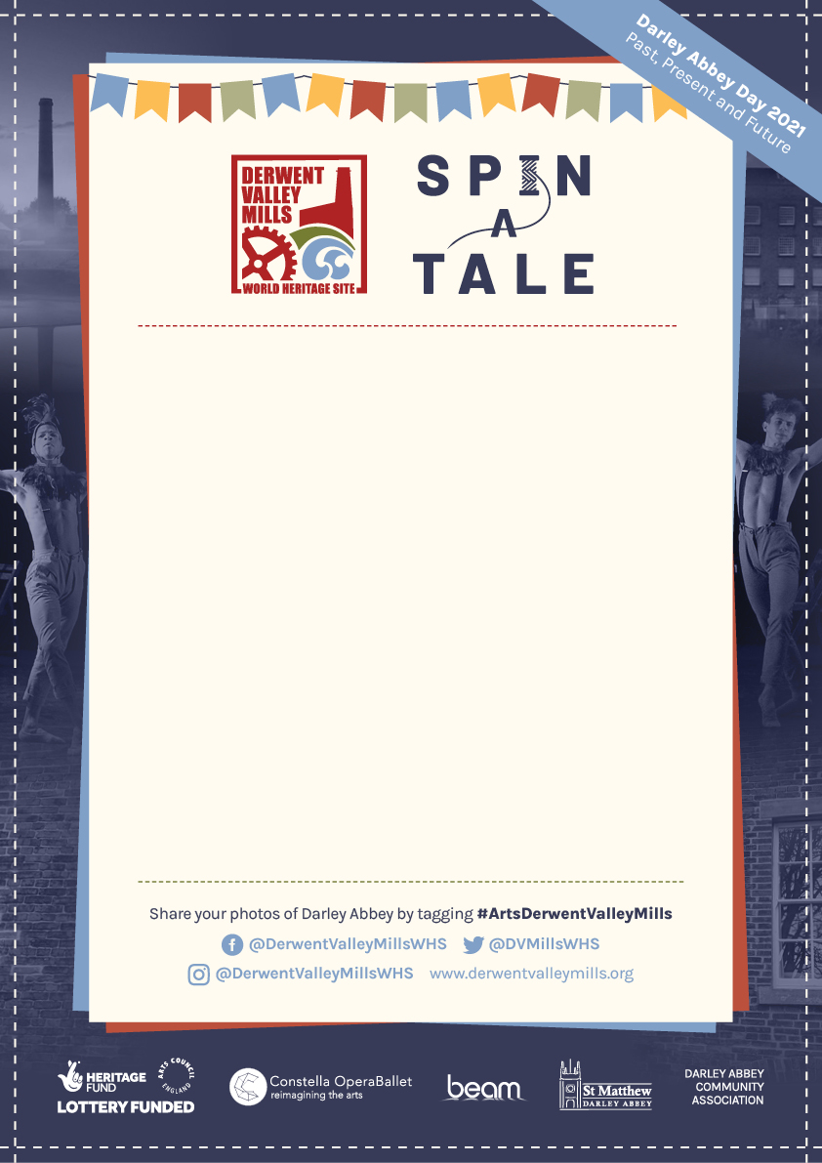
Darley Abbey Day
Saturday 8th May

Bunting Flags
Could you make us one or more?
These are to be a part of the celebrations around the village.
Visit the Derwent Valley Mills website for full details

http://www.derwentvalleymills.org/spin-a-tale-2021/bunting-making/

or contact Janet Dean on:
janet.dean4321@gmail.com

