The operation of the experimental PyroThermic Convertor at Unit 7 of the Northedge Business Park, Derby
1 Introduction
The proposed method of operation of the experimental plant is described in the document Operational Techniques and Monitoring Plan (OTMP) prepared by Enzygo for Envirofusion Ltd. This document assumes the fuel to be Refuse Derived Fuel (RDF) whereas Derby City Council requires the fuel to be Solid Recovered Fuel (SRF). For the drawings and documents submitted originally for the planning application DER/10/16/01241 to be meaningful they need to be redrafted to allow for the change of fuel and the method of handling e.g. omission of Roll on/Roll off handling of the fuel shown on drawing CRM.092.001.PL.D.003B.
2. Conclusions
Gasification plants have been in operation worldwide for 30 years without achieving acceptability. It is concluded from the following analysis that failures in what might be considered conventional heat exchangers, boilers, filtration systems etc. are as critical as failures of any novel combustion processes. There have to be questions asked of monitoring systems in this and other plants as to whether the response time to a deviation from scheduled operating conditions is adequate. The proposed routine monitoring of the process must be questioned with particular reference to dioxins and furans.
When the potential problems that could occur with this plant are considered, the location of it in a residential area and adjoining a storage area for bottled gas e.g. butane, propane, hydrogen, oxygen etc., must be questioned.
3 Definitions
Pyrolisis is combustion without air or oxygen e.g. charcoal burning, with temperatures 750ºC maximum; the output is syngas, unburnt carbon and ash
Gasification is combustion with limited air or oxygen giving temperatures of 1500ºC; the output is syngas and ash with all the carbon consumed.
4. The PyroThermic Convertor (PTC)
The temperature scheduled to be achieved in the PTC is 1500ºC (2.7.2 of the OTMP) and Figure 7.6.5 of the OTMP indicates air input. It is concluded that PTC is a gasification process.
The flow through the proposed plant is indicated on the next page.
5. Feedstock
The process starts with the reception of SRF produced from non hazardous waste, produced presumably in accordance with BS EN 15359:2011 Solid recovered fuels. Specifications and classes. SRF produced to this European Standard has five classes dependent on calorific value and chlorine content. There is no statement on which class of SRF will be used in this plant. SRF, (a) is to be fed into the combustion chamber at 2.75tonne/hour or 66tonne/day through a shredder to a hopper.
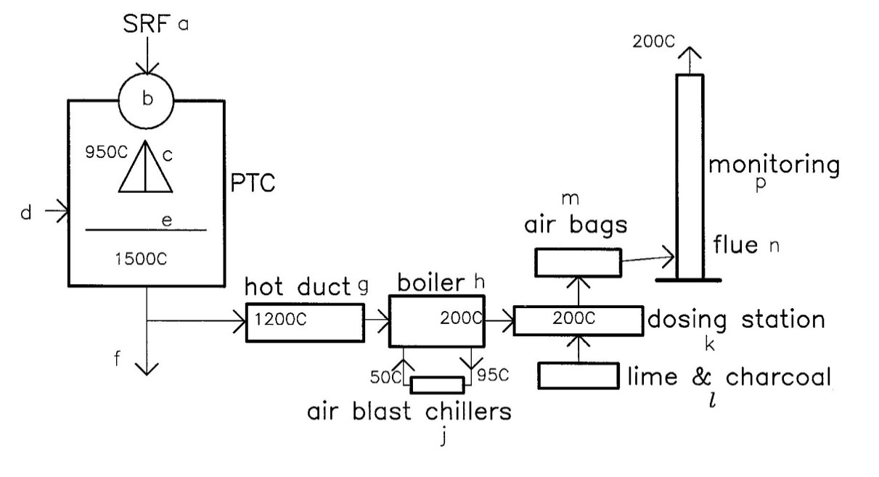
Diagram of flow through plant
6. The combustion stage
From the hopper, SRF is fed into the first stage of the PTC through a controlled airlock valve (b) that prevents gases from within the PTC back flowing out of the PTC. The SRF falls on a rotating cone (c) that distributes the SRF uniformly around the PTC chamber. Additional air (d) can be admitted to boost the combustion process but there is no description in the OTMP of how this is achieved or controlled. The combusting SRF passes through the isolating knife valve (e) that is closed on start up until the temperature reaches 950ºC when it opens and remains open during normal operation. (e) is closed on normal or emergency shutdown. The temperature in the lower part of the PTC is around 1500ºC. The ash component of the combustion is vitrified into a solid residue and deposited at (f). How the very hot solid residue is collected and cooled is not clear. 2.3.8 of the Environmental Risk Assessment says the vitrified molten ash will be deposited in a skip and allowed to cool whereas the OTMP, Derogation Justification, Envirofusion Thermal Process Operating Conditions, says the residue will be discharged through the same hole in the base of the PTC as the gas and collected in a water bath
7. Flue gas cooling
Flue gases emerging from the PTC to the hot duct (g) will be at a temperature of at least 1000ºC to around 1200ºC maximum, This exceeds the Industrial Emissions Directive (IED) limit of 850ºC and the residence time at this temperature, so a derogation of this limit will be necessary.
The gases then pass to a hot water heat recovery boiler (h) that reduces the gas temperature to 200ºC with the boiler water at 95ºC going to air blast chillers (j) for the water to be cooled and returned to the boiler at 50ºC.
8. Flue gas treatment and discharge
The gas passes through a dosing station (k) to capture acid gases and heavy metals by the addition of lime and activated carbon (l) and thence to a bag house (m) where particulates are trapped in filters, The gases then pass to the flue (n) where there is continuous monitoring equipment (p). Gases will be discharged to the atmosphere at 200ºC at a rate of 9m³/second (Air Quality Assessment by Air Quality Consultants Table A5.3.1)
9. Risk Analysis
From the Environmental Risk Assessment by Enzygo for Envirofusion Ltd page 25, the risk of “accidental fire/explosion causing the release of polluting materials to air (smoke or fumes), water or land” has “low probability of occurrence” but both “consequence and magnitude of risk” are classified as “high”. No details on how these assessments were derived is given.
10. A realistic assessment of risk based on operations worldwide over the last 30 years.
Pyrolisis and gasification have been employed for waste disposal for over 30 years. Superficially the process appears to be the answer to the waste disposal problem – low volume and inert residue with acceptable quality gas discharge to the atmosphere and heat generation for energy purposes. So why has there not been widespread take up of the process?
There are two principal reasons for this:
a) the capital and maintenance costs including upgrades and repairs have not matched the return from the energy generated and
b) consistent and continuous performance throughout the whole process of combustion and gas processing has been difficult to achieve.
Under the DEFRA New Technologies Demonstrator Programme, 2004, four gasification plants were scheduled for construction and assessment in the U.K.:
Dagenham withdrawn from the DEFRA scheme in 2007.
Avonmouth opened in 2013, closed in June 2016 and could reopen in 2018 after modification
Newport, Isle of Wight start up in 2008 but ceased operation in 2011 due to dioxin emissions 8 times the prescribed limit; planning permission was granted for modifications in March 2016 and it is anticipated to be running in the summer of 2018
Seamer Carr, Scarborough – see below.
In addition Dargavel, Dumfries, not in the DEFRA programme but running parallel with it, is also described below.
The Seamer Carr incinerator on the southern edge of Scarborough used SRF fuel when it opened in 2009. It ran intermittently until 2011 without passing the commissioning stage. It was then shut down. The process was different from Envirofusion’s proposal but the complexity of the Seamer Carr plant downstream of the combustion chambers showed that risk is as much within the gas processing elements as the combustion plant. Initial operation showed that the situation was “problematical” in early 2009, becoming “highly problematical” towards the end of 2009. Modifications of the plant were required as a consequence. The plant was monitored by the University of Leeds when possible. The lack of monitoring instrumentation meant that insufficient data could be gathered during short run commissioning trials. The steady and consistent operational periods needed to gather data for reliably assessing performance did not exist.
from Research, monitoring and evaluation of the Scarborough Power/GEM pyrolysis facility in Seamer Carr, Scarborough,Yorkshire PT Williams and JR Barton, University of Leeds 2010 for DEFRA.
The Dargavel incinerator commenced operating in 2009 with shutdown in 2013. Operations were halted for 3 months in 2010 due to combustion problems. The plant was closed for 12 months between 2011 to 2012 to redesign and install new boiler systems. Between 2009 to 2011 there were 49 noise complaints, 200 emission limits breaches, 2 dioxin breaches and 100 notices of short term exceedances.
Then between June 2013 when the plant re-opened and August 2013 when the permit to operate was revoked, there were 19 noise complaints, 3 low temperature alerts, 23 low O₂ alerts, 6 dioxin emission breaches, 2 failures of the daily HCl limit, 1 failure of the daily NO₂ limit and 2 failures of the heavy metals limit. It might be anticipated that after the 2009 to 2011 problems attention would have been paid to these issues.
The malfunctions were said to be related to the initial design.
from Air Pollution from Waste Disposal – Not for Public Breath by Zero Waste Europe

It would be anticipated that the design, specification and proposed operation procedures for Avonmouth, Isle of Wight, Seamer Carr and Dargavel, being “show piece” plants, would have been subject to close scrutiny and assessment before the commissioning stage. None of them are currently in operation which is a telling response to the question.

11. The Envirofusion proposal
When the “failures” outlined in 10. are supplemented with the many recorded operating failures throughout Europe, North America, Australia and Japan, many resulting in unforeseen emissions, the question has to be asked whether the Envirofusion scheme, itself an experimental proposal, will function as outlined in the documents submitted with the Planning Application 10/16/01241 or whether unforeseen events such as those described in 10. will occur.

The Envirofusion process can be divided into two parts:
i) the combustion stage and
ii) the disposal of the gaseous products to the atmosphere.
Considering i) briefly, the obvious potential weaknesses are:
- the uniformity and quality of the SRF fuel
- the functioning of the controlled airlock valve
- the functioning of the rotating cone valve
- the functioning of the isolating knife valve
- control of the air input to the combustion chamber
- whether uniform combustion in the PTC can be achieved
- the method of collecting the vitrified ash waste deposit and in particular how the
common gas and waste discharge from the PTC operates
- monitoring of the combustion process and the response time to any observed
departure from specification.
ii) The principal problems are temperature movement of the various elements between the PTC and flue stack and deflagration (fires) possibly leading to detonation (explosion) and how the various elements respond. For example the hot duct shown on the Site Layout drawing as 9.610m long would have a linear expansion/contraction of about 120mm for the temperature range 0ºC to 1200ºC. Similarly the hot water boiler could expand/contract some 40mm and the ducting to the flue stack from the boiler about 50mm. These movements have to be accommodated on every normal start up and every normal or emergency shut down of the plant. Any leakage or failure of the junctions between elements of the plant due to thermal movements would lead to unplanned emissions to the atmosphere. There are sufficient records of plant failures happening in the U.K. and elsewhere in the world for it to be considered a major issue. Deflagration within the plant downstream of the PTC could give rise to a flame wave front that could travel from the PTC to the stack in under a second. This type of failure has caused bag filters to ignite with discharge of particulates to the atmosphere. These are some of the reasons why the location of this experimental plant in a residential area is questioned.
12. The dioxin and furan problem
It is accepted that at temperatures in excess of 1000ºC dioxins and furans break down into their component chemical elements. It is also accepted that in the range 250ºC to 400ºC that dioxins and furans can reform (ref. Characterisation and Control of Dioxin/Furan Emissions from Waste Incinerator Plants, Dr V.Nasserzadeh Sharifi & Professor J.Swithenbank, Sheffield University 2012)
This critical temperature range for dioxin and furan regeneration will occur in the Envirofusion proposal under steady state running in the hot water boiler but could occur anywhere downstream of the PTC on start up and shut down. Chlorine is a major element in dioxin and furan production so the class of SRF used will be critical. For example class 1 must have less than 0.2% of chlorine by weight, class 3 less than 1.0% and class 5 less than 5%. Looking at commercial suppliers of SRF it is most likely to be class 3.
In the light of the unknown possibility of generation of dioxins and furans at this experimental Envirofusion plant and the recorded exceedance of dioxin and furan limits at the Isle of Wight and Dargavel, it is apparent that the proposal to monitor for these products twice a year at the Envirofusion plant is totally unacceptable and this monitoring proposal should be replaced by a continuous monitoring procedure.

P.J.Steer BSc CEng MIStructE 23 April 2017

BS EN 15359:2011
Solid recovered fuels. Specifications and classes

